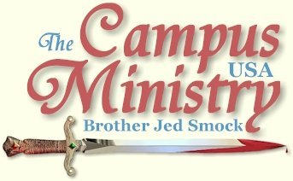
brojed@aol.com
brojed.org
cell:573-999-0346 begin_of_the_skype_highlighting 573-999-0346 end_of_the_skype_highlighting
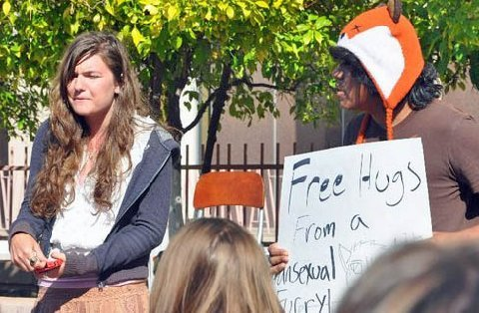

STAFF CRUCIFIX STOLEN

Arizona State University, February 21, 2011

My staff crucifix was stolen today as someone grabbed it out of my hand. Usually, I have the leather strap wrapped around my wrist but unfortunately not today. I took off running after the thief but he had too much of a jump on the old man. I am surprised no one has tried to steal it before. I had gotten lax in making sure it was wrapped around my wrist. I never leave it unattended.
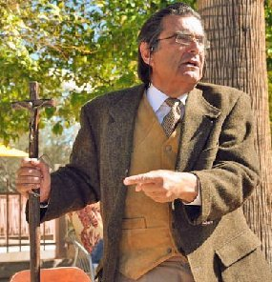
Staff just before it was stolen.

Martha and others got his picture. I did make a police report so if the police really pursue this with the picture we should be able to find the thief. The staff had sentimental value since an old friend custom made it for me and I have not only carried it all over the country but to Ghana, Africa. As a student said the staff was “a work of art.”
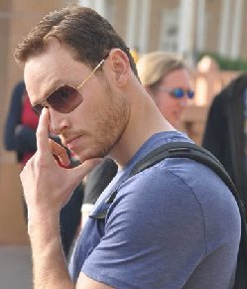
Crucifix Thief
We arrived on campus too late for the noon break as I made a couple of wrong turns on my way to campus. It may not have made too much difference because loud music was playing over the noon hour. It hindered me for the 1 PM break.
Samuel, an agnostic, stopped at 1 PM and I had a good talk with him. He was relatively open. By the 2 PM break the music had stopped. I gathered a crowd of about 20, which eventually reached close to 100. There was a Jehovah Witness, or as I prefer to call him an Arian, who was loudly opposing my preaching. I was suspicious of him when he tried to butt into my conversation with Samuel. John G., a local businessman, who preaches on campus once every two weeks, has also had some interruptions from this heretic. He denied the deity of Jesus and objected to my preaching of the fear of God. I cannot remember having such a confrontation with a JW. They are usually pretty laid back.
There was another fellow with a wool hat shaped like a fox’s head. He was pleading for sin and objecting to my lack of love. Both the Arian and the fox’s head were loud and boisterous.

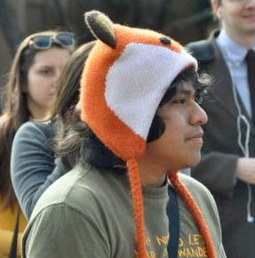
"...He was pleading for sin and objecting to my lack of love..."
A few Moslem men were present who also aggressively opposed the deity of Christ. As least the Arian did rebuke them for not believing that Jesus is the Son of God. The Moslem men did not stay around long. There were two veiled Moslem girls, who listened for a couple of hours. When I warned the students about the premarital kissing, I asked the Moslem girls if they thought premarital kissing was wrong. They agreed that it was. I responded, “Christian and Moslems agree on one thing.” One of the girls said, “I don’t agree with you on anything.” But I got them to admit that there is a Heaven to gain and a Hell to shun. These girls were hot heads and one of them threatened me when I spoke disparagingly of the Koran. Last year a Moslem girl on this campus stole my Koran. After which to cover for her, some Moslem claimed that I hit her with my staff, which was a lie. But soon much Moslem community rallied and were as enraged as the protestors in the streets of Egypt and other Moslem countries.
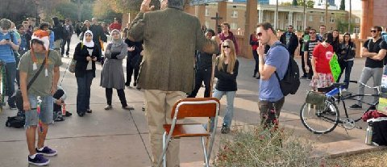
Fox head heckler on the left, two Muslim females center
left and crucifix thief on the right!

I warned the students that Moslems can be very volatile. A fact of which they were aware, but hardly anyone (except me) dare say. I said, “Regrettably, we have our counterparts, the socialists, who are protesting in the state capitol of Wisconsin.”
Someone responded, “Like our American Revolutionaries.” I countered, “Our fathers were not demonstrating for days in the streets and not working. Independence was declared through Colonial Legislators which sent delegates to form the Continental Congress.
At one point a heckler was making rabbit ears behind me. Then he grabbed me from behind. I turned and warned him not to touch me. Then Martha Marie was stirred and got in his face and sternly admonished him as she made a shoving motion but was careful not to touch him, “You get away from my Dad.” The boy had a startled look on his face and got down from the wall. He caused no more problems. Martha does not like anyone messing with the old man. Martha is somewhat shy in public but she is fearless in explosive situations.
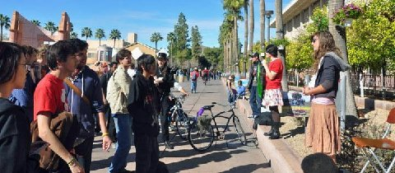
"...Martha ( far right) is somewhat shy in public but she
is fearless in explosive situations..."
Shortly, afterwards the crook stole my staff. When I took off running after him a few students chased him as well. But they did not react soon enough to stop him. One of the boys later apologized for not reacting more quickly.
After I got back from the chase, the Arian rebuked me for caring about my staff more than staying around to preach to the crowd. He thought that I ought to forgive the thief instead of calling the police. He had been opposing my preaching all afternoon. He was looking for an excuse to find fault. The fellow, who had apologized to me for not reacting more quickly, then told the Arian to shut up. The Arian, who was a hothead, and seemed to have anger issues got into the face of the man who rebuked him. I thought that a fight might ensue. However, it did not turn violent.
The policeman came on the scene. He was helpful and drove me through campus looking for the thief. But we could not find him. By the time we got back to the preaching area it was 5 PM and I decided to call it a day since we had a dinner appointment.
Dinner was with a psychiatrist friend. The doctor confirmed what I have been writing that there is no physical test to determine the chemical makeup of the brain. Also, there is no definite standard for determining what the normal chemical makeup of a healthy brain is.

BREAD, MEAT AND WATER THEY KNOW NOT OF

ASU, February 22, 2011

Religious groups were set up across from where I preached including, Moslems, Jews, Eastern religionists and various Christian groups. They were giving out free food and drinks, mostly pizza. I thanked them for what they were doing in feeding the people. I told those passing through the Mall that I had no cokes, bottles of water or pizza, but I did have living bread and living water for them to eat and drink. I exhorted them to drink of the new wine and eat of the flesh of Jesus. No one seemed to be interested at the two breaks which I preached.
I decided to go back to the car to get two sandwich board signs. When I returned, Samuel was hanging around and I had more good conversation with him. I held up one of my signs which had lists of sins. The one that always gets the questions is socialism. After 2PM the atheists set up their table, so I moved my location closer to them figuring I would get some dialogue going. I finally got a crowd about 2:30.
Monte Botts, who has been roaming the campuses for years with his leased dog, interrupted me. Monte who lives out of his van has the look of a homeless desert rat. Monte does what he calls signing, holding up a sign with only occasional remarks. His dog helps him get attention since so many of the girls are dog lovers. He told those gathered that my confrontational style and talks on sex were wrong. Monte rarely ever gets an audience because he does not confront sin, but he likes to take advantage of speaking to my crowd. I warned Monte that he was out of order. I fear the poor man has demons, which vex him and egg him on. I warned Monte that devils were stirring him up, but he ignored me.
Meanwhile, the Hispanic with the wool fox hat, who has nothing but the love message, also loudly interrupted. Next the Arian, JW, guy from yesterday was speaking vociferously.
Then there was a girl who had been converted out of paganism and was baptized into Mormonism over the weekend. The Mormons still have a lot of work to do with this foul mouthed female. She admitted that she had been addicted to sex and cokes, evidently the cokes had rotted her teeth, so at least the Mormons could help her in this area.
I could hardly get out a message with four fanatics running their mouths, for some of the time they were all speaking at once.
I decided to call on Martha hoping that the she might settle down the demons which were causing chaos. Martha asked, “What shall I do?” I did not have an answer, so I said, “Whatever you can.”
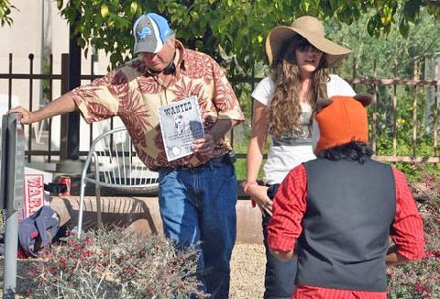
Bro. Thomas is holding up the wanted sign
while Martha takes on the Fox Head.

By this time the fox head Hispanic was acting up the most. Martha began rebuking him for being so annoying. Martha was doing a good job standing against him. I sat in my chair in the middle of the crowd, every now and then making a remark. Eventually, by sharing some of my past life I was able to regain the attention of the crowd. But Monte interrupted during my testimony to give a sermon. This time what he had to say wasn’t bad. Monte told how he had been converted through my ministry and filled with the Holy Spirit at Tucson about 30 years ago, which must have thoroughly confused the students.
We had, “Thief Wanted,” fliers with my staff stealer’s face, which we showed to the crowd many times. But no one was able or else willing to identify the thief. We are in communication with the police, who do have a lead, hoping they will catch the criminal.

Thomas, who is a retiring from the school system, has been working with us. Thomas spends a lot of time on campus. He is a good help and witnesses one on one.
I had a crowd of fifty listening after 5 PM, but my hosts were expecting me for dinner at 6PM so I had to leave the lost souls who were still hungry to hear more. All the soft drinks and pizza that the religious groups had fed them did not satisfy the hunger of their wretched souls.

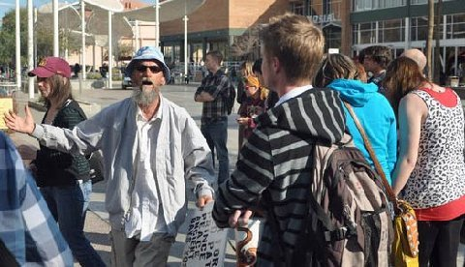
Monte Botts--a thorn in the flesh and a sad case

MY ARMOR BEARER
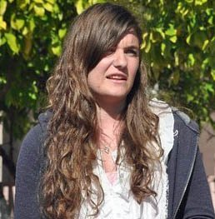
Martha Marie, "The Lioness"

ASU, February 23, 2011

A quiet boy in the crowd came up to me and politely asked, “Can I look at your Bible?” I hesitated. He said, “I only want to look at it for 20 seconds.” He looked harmless and sincere. I assumed he wanted to look up a verse. When I handed him the Bible, he ran off with it.
I turned and said, “Hey, Martha that guy stole my Bible.” Martha kicked off her flip flops and like a gazelle ran after the thief. She caught up with him and yelled. “Give me my Dad’s Bible back!” When he refused, Martha jumped him, but he held the Bible away from her. Martha punched him in the stomach and put him in a head lock. He threw the Bible aiming for the trash can, but he missed. Martha leaped for it while throwing her fist back and knocked him in the head. Apparently, except for his pride, he was not hurt and walked off. And Martha triumphantly presented me my Bible with my compliments. The cover of the Bible reads, “The Military Bible.” It is an edition frequently used by the armed forces.
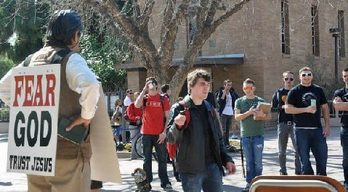
Bro. Jed Holds the Bible that Martha Marie Rescued!
Evangeline was a Chaplain’s Assistant for 5 years in the Army. Her role was to protect the Chaplain since he does not carry a weapon. Now Evangeline really never had the opportunity to defend the Chaplain since she was never deployed. Martha has been deployed to God’s fields of battle and she and I are on the fighting for Truth every day. This is the second time this week she had to display a show of force for my protection. Her mother after hearing of today’s incident wrote on Martha’s wall, “You remind me of Deborah of old, just don’t go as far as Jael.” Missionary Gary Lukas wrote, “You have a lioness for an armor bearer.”
After she returned with the Bible, the Arian and the “pansexual” professing Catholic with the fox head cap claimed that Martha should not have reclaimed my property. Martha was admonished by a few “for getting in the flesh.” There is much misunderstanding about this idea of a Christian getting in the flesh. Many do not have a clue as to true spirituality. I suppose some would claim that David got in the flesh when he slew Goliath or blinded Samson when he brought down the walls on the Philistines. Many Christians need to understand that there are times when using force is spiritual, and not to exercise force would be fleshly. I understand that sincere people may disagree as to when force is necessary. We should not resort to violence. Violence is an illegitimate use of force.
The day started inauspiciously. Monte was haranguing without an audience upon my arrival which is unusual for him, usually he just holds his sign with occasional remarks. When he does preach, he mostly speaks out against the church. He seems to consider all the churchmen as Pharisees. When I arrived, he started preaching against confrontational evangelism. Monte’s preaching is hard to follow. It is mostly a stream of consciousness. Finally, someone from the Chi Alpha tent cried, “What are you preaching?” I considered this a fair question. Monte rebuked them for not preaching in the open-air. I discovered as I listened to Monte he does not believe in the Trinity or the deity of Christ.
Samuel, the agnostic, who is hung up on the doctrine of eternal torment in Hell engaged me in conversation again. Eventually, others joined us. I did not start preaching until around 1 PM. It was easier gathering a crowd today. But it was another hectic day because of loud mouths like Monte, the Arian and the pansexual with the silly hat. Today a loud Moslem joined him. He objected to me calling them Moslems instead of Muslims. Of course, I make it a point to be politically incorrect.
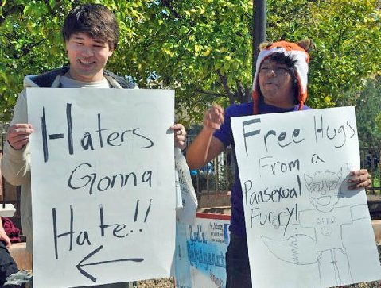

Once again I played the Martha card hoping that she would subdue the loud mouths. However, even Martha could not calm them down. The pansexual love bird did a lewd dance too close to me for about 15 minutes. I have concluded that he must pose as a drag queen off campus.
There are demons all over ASU. Does the fact that this school is called the ASU Sun Devils draw demons?

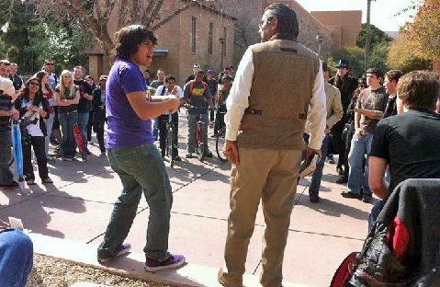
ASU, Where Devils Abound and Grace Much More Abounds!
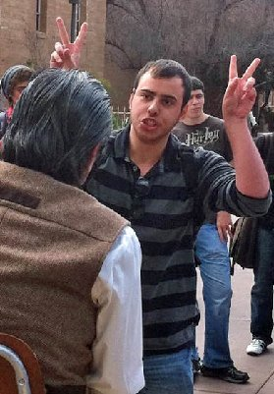

At the beginning of the day a Christian by the name of Benjamin introduced himself. He complimented me for my effective use of satire and comedy to illustrate some hard truths. He is a disciple of a local minister, Pastor Eric, whom I know. Benjamin said he first heard me several years ago; he did not consider my message to be of God. Pastor Eric exhorted him to listen more carefully. And he watched the videos of my more sensational material the students post on youtube. He came to comprehend my message and methods. I was especially encouraged because I have in the last week received a considerable amount of criticism for my parables which satirize students’ sins. The boy had an understanding of my tactics. I was also encouraged that a local pastor defended my ministry.
Thomas stood with us again today. Martha and I left campus at 4:30 PM. We rejoiced in her exploits on the drive back to where we are staying.
Martha’s action was a good testimony that Christian women are strong. When I speak out against the feminist movement, some may get the wrong impression that I expect women to be weak. They do not understand that through submission and obedience to authority (fathers and husbands) women will find strength. An independent and rebellious spirit breed’s weakness and warps the personality, which in a woman is to be “meek and quiet, which is in the sight of God of great price.”—1 Pet 3:4.
Martha is precious to God. Anyone who knows the Smocks, mother and daughters, knows they are not powder puffs.
Regrettably, meekness is often associated with weakness. Moses was very meek above all the men which were on the face of the earth.—Number 12:3. Yet, Moses was the mightiest man of his day. Jesus said, “I am meek and lowly of heart.”—Matt 11:29. Yet, Jesus was the Almighty God in the flesh. As both women and men submit to God, they find might and power.

SEX ED WITH BROTHER JED

ASU, February 24, 2011

Occasionally, I will get a good line from a heckler. The Arian, who has been interrupting me all week with his heresy, was mocking my style of teaching the students on human sexuality and basic anatomy. He coined the phrase “Sex Ed with Brother Jed,” suggesting that all I talk about is sex.
It wasn’t until after 1 that I gathered about a dozen students. It has been so hectic this week that I have had trouble telling some of my well-known stories and illustrations. I have not been carrying with me the electrical cords for a year or so. I have found that finger motions illustrate my points well enough. I think my cords were stolen somewhere along the road.
A few of the regulars asked, “If we buy the electrical cords will you do the demonstration on how to have proper sexual relations?” I promised that I would. Fifteen minutes later they returned with the cords. Illustrating the birds and bees with the cords succeeded in drawing the students in and I soon had a crowd of over fifty. Most of them were recording my Sex Ed on video.
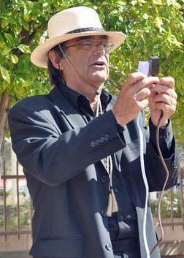
"...A few of the regulars asked, 'If we buy the electrical cords will you
do the demonstration on how to have proper sexual relations?'”
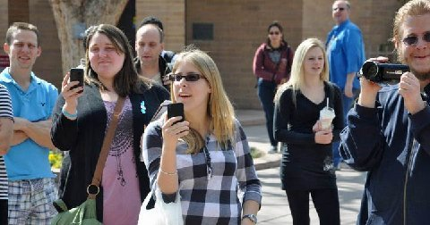
Capturing the Message on Video!
Monte was “signing” when I arrived on campus so I found a place on the wall of the mall down a piece from him. He came down with his friend and wanted to pray for my back. I replied, “My back has been healed. If you really want to be helpful, quit interrupting my meetings. Pray that the Lord will give you self-control.” I also told him I would prefer if he would not tell people he was converted through my ministry. Later he gave his testimony and told how he had been converted through my ministry at UA in Tucson decades ago. Oh, well, I suppose Monte is not as bad as Judas.
Monte went into one of his almost incoherent diatribes about his opposition to the Pharisees and the Churches and confrontational evangelism. Without exception I find preachers who cannot say anything good about any church or other ministers have serious issues. There was a mature student believer among us from Campus Crusade who began to ably defend the Trinity and Deity of Christ to Monte and another man who agreed with Monte. I was glad that he diverted Monte’s attention from me.
Thomas suggested to me that Monte does not believe in the deity of Christ because he does not really want to submit to Christ’s authority. This may be Monte’s problem. He does not recognize any ecclesiastical authority so he won’t submit to the authority of Christ and acknowledge that he is God. Monte is a law unto himself.
The pansexual with the silly fox’s hat was also back again. A fellow who was acquainted with my ministry from others campuses drove up from Casa Grande to hear me today. He said, “I heard several people say in the crowd that they wanted to listen to you and not the other preachers.” The Arian can wax eloquent at times, but I detect a bad spirit behind his bad doctrine. It is too bad because he has a good voice and vocabulary but there is a presence of darkness about him.
Today, Averroes, a Muslim turned secular humanist, challenged me to a debate or informal discussion tomorrow evening, which is to be sponsored by the Secular Free Thought Society.
There were no incidents or altercations today. Martha always gets stirred when she is accused of having a tyrannical father. She will start yelling at the students. That is when I like to call upon her. She takes attacks against her dad and family life very personally and she becomes enthused with righteous indignation.
I had to leave a sizable crowd to Monte and the Arian at 4:30 since I had an evening speaking engagement for the Evangelical Sisters of Mary at Canaan in the Desert where I am being hosted. Speaking of ministries, it is one of the best para church organizations that I know. The ministry was founded by Mother Basilea Schlink in Germany after WWII. The Sisterhood grew and in 1968 a branch was founded in Phoenix. Where they tend a beautiful prayer garden with the Stations of the Cross and concentrate on sending Mother Basilea’s books throughout the world. I have been friends with the Sisters since the mid-seventies. We are one in the Spirit.

AVERROES, THE MODERN

ASU, February 25, 2011

As we were waiting on the class break, Monte walked up and seemed to have a humble attitude and admitted that perhaps his problem was a lack of submission to any ecclesiastical authority. He admitted that he had been vexed of late with Jehovah Witnesses and Mormons talking to him. This is a pattern that I have seen in Monte over the years that he will appear to be humbled but it does not last long.
A disciple of the Arian who has been interrupting all week came up and started discussing the issue. Soon a spirit came over Monte and he reverted to his contentious and erroneous ways. The Arian disciple was speaking loudly; I sensed no openness and I did not want to hear his heresies or waste my time trying to convince him. After I made a few remarks in defense of the Trinity, I moved on down the wall and took my stand across from the Secular Free Thought Society table. I would rather dialogue with them than fanatical preachers.
I raised my voice to preach even though there were not many passing at this time. Monte and the disciple of the Arian came down and began ranting me. The demons were all over poor Monte. It is dangerous to try to walk alone with the Lord. I told him he needed to join a Calvary Chapel. He told me he had been kicked out of Calvary Chapel. He was yelling at me and then at the crowd while I was trying to preach. It was too chaotic to get a message across. So I read from Hebrews 1 with comments. In this chapter Jesus is said to be the one “who made the worlds (vs. 2)” and the Father refers to his son saying, “Thy throne, O God, is forever and ever,” in verse 8. I read Rev. 1:8 where Jesus refers to himself as “the Almighty.” Then I read and commented on select passages from John 1.
Meanwhile, another fanatic was stirred up against me who began rapping at the top of his voice. The frenzied situation did draw a crowd. Eventually, the demons ran out of gas. Then the pansexual with the silly hat arrived. He was somewhat calmer today but still stood beside me for over an hour holding his sign. For most of the afternoon the crowd was 20-30 people.
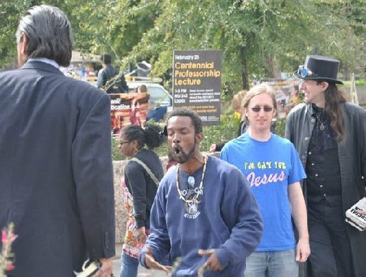
Crazy Rapper

These Guys are Listening!
John G. arrived about 2 PM. I called upon him and he spoke out against socialism and referred to God as a capitalist. Students kept bringing up the issue of evolution. John’s response was, “Before we discuss evolution, you tell me how something came from nothing.” John actually had the crowd more stirred than I did. We preached until about 4:30 when the crowd died out.
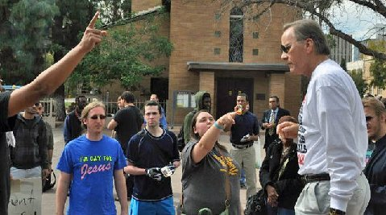
“Before we discuss evolution, you tell me how something came from nothing,"
Bro. John.

We arrived at the debate classroom at 5:15. I sat beside Samuel, who I have talked extensively with daily. He is a T.A. teaching English Composition. Late in the afternoon he asked me to sign a copy of a Gideons’ N.T. I inscribed, “Read, Study and OBEY.” He brought his N.T. to the debate. He asked where I suggested he start reading. I said, “Billy Graham suggests people start with the Gospel of John. I also advised Proverbs because it is a good book for developing wisdom and character. He asked, “What are your favorite passages in Proverbs.” I referred to Proverbs 1 and we read together Proverbs 1:20-33. I also took him to Proverbs 4. He admitted that there were some beautiful passages in the Bible and he had to retract his statement to me of a previous year that the Bible was poorly written. I remember that I was shocked that an English teacher could say such a thing. Since Samuel has a philosophical bent, I also suggested Ecclesiastics and talked of the themes in that book. I was quite encouraged after this conversation with Samuel that he may be opened to the Bible.
At 5:45 I had an informal debate with Averroes, Muslim turned skeptic, on faith, hope and love. I spent five minutes speaking on each of these subjects. After I finished Averroes said, “It is difficult to top that but I will try.”
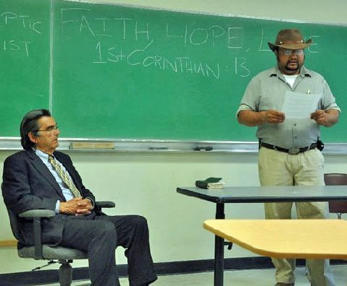
Muslim Turned Sceptic Debates Bro. Jed
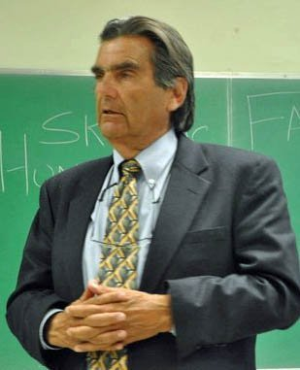
"...The Skeptic Society has sponsored debates for the
last three years that I have been on campus..."
Averroes went five minute over his allotted 15 minutes. Samuel, the moderator did not stop him. His final point was, “Incredible claims require incredible evidence.” I responded during my rebuttal that atheism is an incredible claim that something comes from nothing and intelligence comes from non-intelligence and life comes from non-life. Also I pointed out that the vast majority of those considered to be the greatest minds of history were at least theists, including one of the most respected Moslems in history, Averroes of Cordoba. Only in modern times have atheists gained credibility. Still one could name 10 great philosophers or scientists who were theists for every atheist in history. I thought my point was strengthened when Averroes admitted that he had chosen this name for himself.
In the many debates that I have had, I have a significant advantage because I am always a much more seasoned speaker than my opponents. Averroes is verbose, which I thought weakened his arguments. During the Q & A from the audience of over 25 people his answers were usually at least twice as long as mine. One needs to learn in too keep their answers short and to the point and not make try to say too much.
Everyone was courteous and respectful and all seemed to appreciate our debate/discussion, which both Averroes and I considered productive. The Skeptic Society has sponsored debates for the last three years that I have been on campus. I appreciate their openness. They are a likeable bunch of blasphemers. I have a higher opinion of them than I do lukewarm Christians. Averroes, as an apostate Moslem who speaks out boldly against his old religion, is vulnerable; so I respect him for the courage of his convictions.
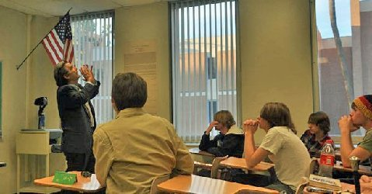
"...atheism is an incredible claim that something comes from nothing and intelligence comes from non-intelligence and life comes from non-life..."
I mentioned to Martha that I hate to leave Arizona. I love this state and especially enjoy UA and ASU, UA more than ASU. I thrive in the desert and think that I could make a home in the desert. My skin has turned to leather over the years from being in the sun so much. And my lungs have become leather from much use.
It looks like I will be leaving Phoenix without my staff. I have carried it everywhere including abroad the last few years. The Sisters are praying that the Lord will use the crucifix to bring conviction to the thief. My custom staff crucifix was a powerful religious symbol. I am praying that the Lord will provide me an even better one. He is able to do that…
Saturday, February 27, John G., the maker of the stolen staff, presented me with another one.

Thank you for your faithful prayers and support. Please continue to pray for us. You may donate to CMUSA using PayPal by going to our web site brojed.org or by mailing your check to our home address: CMUSA 2402 Longview Dr. Columbia, MO 65203. All gifts are tax deductible. Thank you for your generosity.

